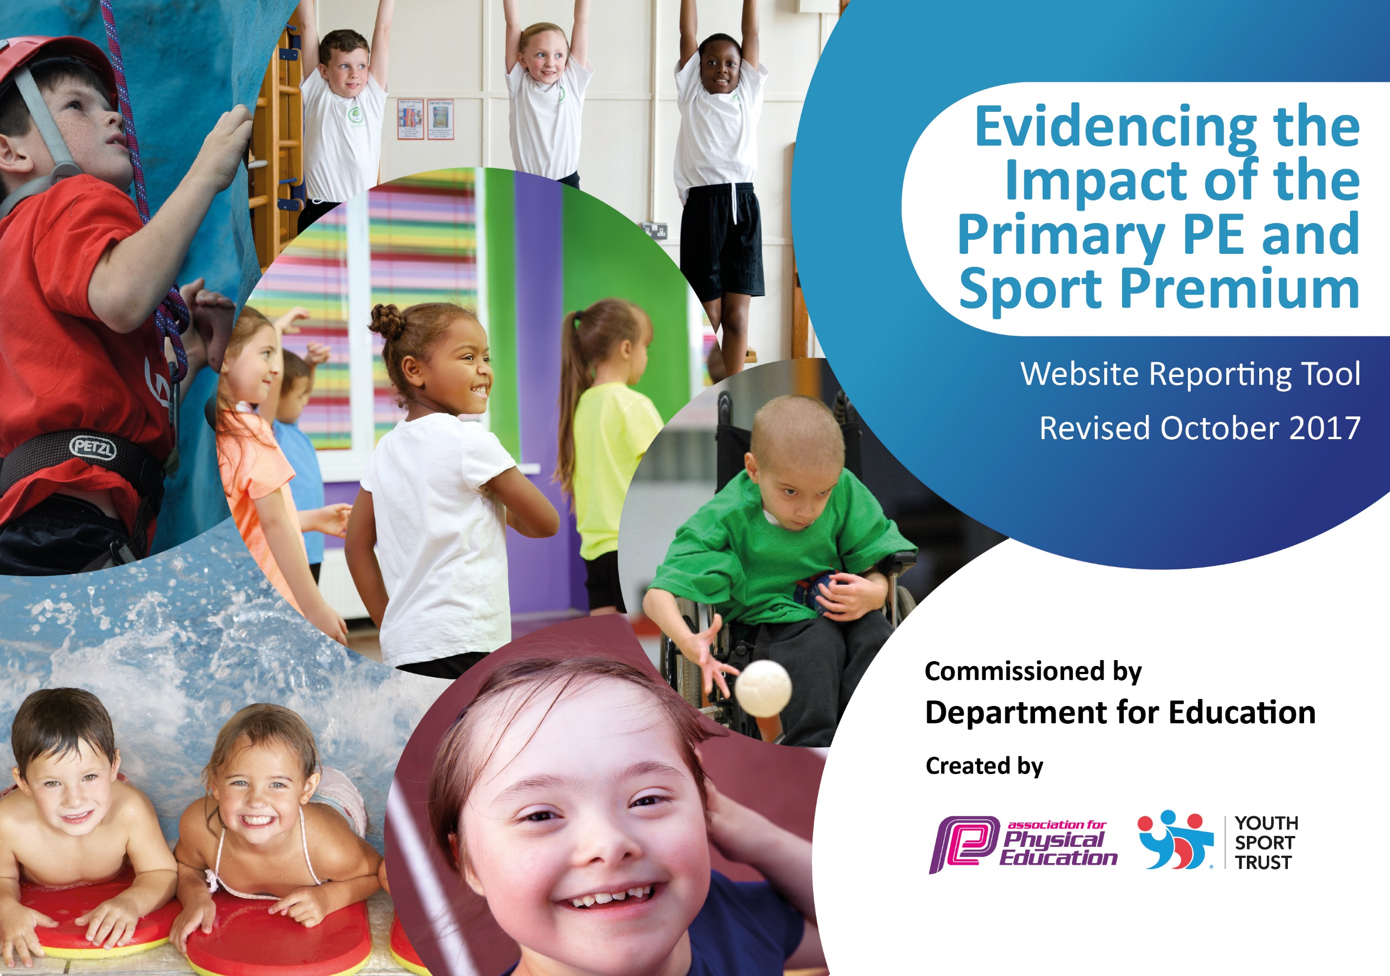
Year 2018/19 Fairfield Primary School

Schools must use the funding to make additional and sustainable improvements to the quality of PE and sport they offer. This means that you should use the Primary PE and Sport Premium to:

- develop or add to the PE and sport activities that your school already offers
- build capacity and capability within the school to ensure that improvements made now will benefit pupils joining the school in future years

Please visit gov.uk for the revised DfE guidance including the 5 key indicators across which schools should demonstrate an improvement. This document will help you to review your provision and to report your spend. DfE encourages schools to use this template as an effective way of meeting the reporting requirements of the Primary PE and Sport Premium.

We recommend you start by reflecting on the impact of current provision and reviewing the previous spend.
Under the Ofsted Schools Inspection Framework, inspectors will assess how effectively leaders use
the Primary PE and Sport Premium and measure its impact on outcomes for pupils, and how effectively governors hold them to account
for this.

Schools are required to publish details of how they spend this funding as well as on the impact it has on pupils’ PE
and sport participation and attainment.
We recommend regularly updating the table and
publishing it on your website as evidence
of your ongoing review into how you are using the money
to secure maximum, sustainable impact. To see an example of how to complete the table please click HERE.

Support for review and reflection - considering the 5 key indicators from DfE, what development needs are a priority for your setting and your students now and why? Use the space below to reflect on previous spend, identify current need and priorities for the future.

Key achievements to date: | Areas for further improvement and baseline evidence of need:
We offer a gifted and talented program for talented sports persons.  We offer Sports Development Programme to all Year 6 children.  Quicksticks Hockey Yr 3/4 Champions 16/17.  Tennis Yr 3/4 Large School Champions 2017 .  Duathlon Yr 4, 5, 6 2017 3 Golds, 2 Silver and 3 Bronze medals.  Quick Cricket Yr 5/6 Champions 2017 – competed at county finals.  Rugby Yr 5/6 Boys Champions 2017 .  Rugby Yr 3, 4, 5, 6 Girls Champions 2017 .  High 5 Netball Yr 5/6 Champions 2017 .  Quicksticks Hockey Yr 3/4 Cockermouth Champions 17/18 .  Quicksticks Hockey Yr 3/4 Regional (Level 2) Champions 2018.  Sportshall Athletics Champions 2017 .  Girls 5-A-Saide football competition 2nd in County Competition.  21 children participate in County Cross Country competition – one child selected to compete at National Cross Country event.  Rugby competition 1 finished 5th Place.  Rugby competition 2 Champions 2018.  Tennis Yr 3/4 Champions 2018 (the 2 teams we entered finished 1st and 2nd).  Yr 6 Football competition Cockermouth Champions 2018.  Cockermouth Cross Country Competition 2018 Fairfield A, B, C and D running teams finished 1st, 2nd, 4th, and 9th! 2 Winners of the year 3/4 race and 5/6 Race.  Year 3/4 Rounders competition – whole of Year 3 participation and also the Winning team.  Year 5/6 cricket completion, Keswick, champions 2018.  Allerdale Cross Country Competition Year 4 girls Champions and Year 5 boys Champions.  Year 5/6 Rotary Club Football Competition Champions 2018.  Year 4 Tag rugby competition CRUFC 2018 Champions 2018.  Quicksticks Hockey Yr 3/4 County (Level 3) 3rd place 2018.  Touch rugby KS2 Girls Champions CRUFC 2018. | Within the upcoming academic year, we will strive to ensure that there is a rise in participation for competitive sports by all children.  Increase inter– school competitions, preparing children for external competitions.  Increase staff CPD through twilight training in order to refresh their knowledge of core sports for upcoming competitions.  Utilise IPEP programme in order to assess, plan and record lesson outcomes whilst ensuring we continue to teach an array of lessons that meet the needs of our classes, prepare children for upcoming competitions and ensure that plans fall in line with the yearly overview of each class.  We will continue to build upon children’s involvement in regular activity through use of durable and effective play time boxes designed and organized by the school council that will be monitored by sports leaders.  Develop Feet First Programme by introducing ‘Walk Wednesdays’.

Meeting national curriculum requirements for swimming and water safety (for year 2017/18) | Please complete all of the below:
What percentage of your Year 6 pupils could swim competently, confidently and proficiently over a distance of at least 25 metres when they left your primary school at the end of last academic year? | 88%
What percentage of your Year 6 pupils could use a range of strokes effectively [for example, front crawl, backstroke and breaststroke] when they left your primary school at the end of last academic year? | 88%
What percentage of your Year 6 pupils could perform safe self-rescue in different water-based situations when they left your primary school at the end of last academic year? | 88%
Schools can choose to use the Primary PE and Sport Premium to provide additional provision for swimming but this must be for activity over and above the national curriculum requirements. Have you used it in this way? | Yes

Action Plan and Budget Tracking
Capture your intended annual spend against the 5 key indicators. Clarify the success criteria and evidence of impact that you intend to measure to evaluate for students today and for the future.

Academic Year: 2018/19 | Total fund allocated: 18,000  Total fund outlined below: £18,000 | Date Updated: 14/10/18
Key indicator 1: The engagement of all pupils in regular physical activity – Chief Medical Officer guidelines recommend that primary school children undertake at least 30 minutes of physical activity a day in school |  |  |  | Percentage of total allocation:
 |  |  |  | £3500 20%
School focus with clarity on intended impact on pupils: | Actions to achieve: | Funding allocated: | Evidence and impact:  To be reviewed 2019/20 | Sustainability and suggested next steps:
Develop play provision.  ‘Walk Wednesdays’ promoted throughout KS1 and KS2.  Active Families based on parent’s feedback.  1K a Day | Allocated play time leaders will be involved in organising durable boxes with suitable equipment for each year group that can easily be accessed. Develop KS1 provision.  In class target boards personalized to each class that will be shared termly in assembly.  Use of the Feet First Programme/ Hands Up Survey to encourage use of different modes of transport to get to and from school.  Timetabled sessions that are devised with families personal targets as a key focus for each session.  Continue whole school involvement in 1K a day. | £2500  £0  £1000  £0
Key indicator 2: The profile of PE and sport being raised across the school as a tool for whole school improvement |  |  |  | Percentage of total allocation:
 |  |  |  | £2750 15 %
School focus with clarity on intended impact on pupils: | Actions to achieve: | Funding allocated: | Evidence and impact:  To be reviewed 2019/20 | Sustainability and suggested next steps:
Fully implement and utilise IPEP program, Maths of the day and 5-a-day across whole school.  Inter-house competitions are financially viable and can be developed to enhance in-school, inter-house competition.  Ensure continued use of Sports leaders for daily provision for all KS2 children and explore upskilling of Mid-day supervisors to enhance KS1 (and further enhance KS2 provision). | INSET day review training for all staff.  Focused staff meetings where year group partners can monitor children’s progress and amend planning for the sequential terms.  PE sessions timetabled for each year group cross referenced with class overviews and whole school timetable for competitions ( Chris Wright Services, Allerdale and Cockermouth School Competitions).  All coaches/ staff delivering core sports to organise both inter- house and inter- school competitions at the end of each block.  Potential to draw up a Key Stage league table for each year group to be shared and celebrated in Summer 2.  Bibs for each house colour.  CPD opportunities/ coaching for Mid-day supervisors so that they can timetable weekly activities for children in KS1 and deploy equipment appropriately using the play time boxes. | £2000  £250  £500

Key indicator 3: Increased confidence, knowledge and skills of all staff in teaching PE and sport |  |  |  | Percentage of total allocation:
 |  |  |  | £750 4%
School focus with clarity on intended  impact on pupils: | Actions to achieve: | Funding  allocated: | Evidence and impact:  To be reviewed 2019/20 | Sustainability and suggested  next steps:
Provide additional CPD opportunities for staff for Gymnastics and core skills.  To further implement Maths of the Day inside and outside of the classroom. | Core sports i.e. High 5, Quick sticks, Quick cricket, Sportshall Athletics, Tag rugby to be explored and enhanced during twilight sessions to develop staff awareness and understanding of how the sport is played providing an opportunity to refresh knowledge prior to the upcoming competitions in the school timetable.  Staff to record MOTD in children’s books and lessons to be shared with parents on class dojo. | £250  £500
Key indicator 4: Broader experience of a range of sports and activities offered to all pupils |  |  |  | Percentage of total allocation:
 |  |  |  | £7,000 39%
School focus with clarity on intended  impact on pupils: | Actions to achieve: | Funding  allocated: | Evidence and impact:  To be reviewed 2019/20 | Sustainability and suggested  next steps:
Grand-day Out  Sports Development  Climbing Wall | A suggested £1 contribution to cover the cost of transport is required to ensure that the Grand Day Outs can take place.  Specialist coaches will continue to work alongside staff in school. They will work alongside the children to develop skills and also identify those who will benefit from after school sports development club.  Sports Leaders and Mid Day Supervisors will be responsible for ensuring the climbing wall is used effectively to develop gross motor skills across KS2.  KS1 staff will ensure that the children use the climbing wall to develop gross motor skills. | £1000  £6,000  £0
Key indicator 5: Increased participation in competitive sport |  |  |  | Percentage of total allocation:
 |  |  |  | £4,000 22%
School focus with clarity on intended  impact on pupils: | Actions to achieve: | Funding  allocated: | Evidence and impact:  To be reviewed 2019/20 | Sustainability and suggested  next steps:
We will aim for 75 % of all children to participate in a competitive sport. | INSET DAY: share new arrangements for organising competitions where class teachers and specialist coaches will choose, select and take their own class to competitions.  Introduce new format of coaching and competitions for the whole year to all staff.  Participate in Allerdale, Cockermouth and Wright Sports Services Multi Skills and Football competition in addition to Level 2 Sports. | £500  £0  £3500

