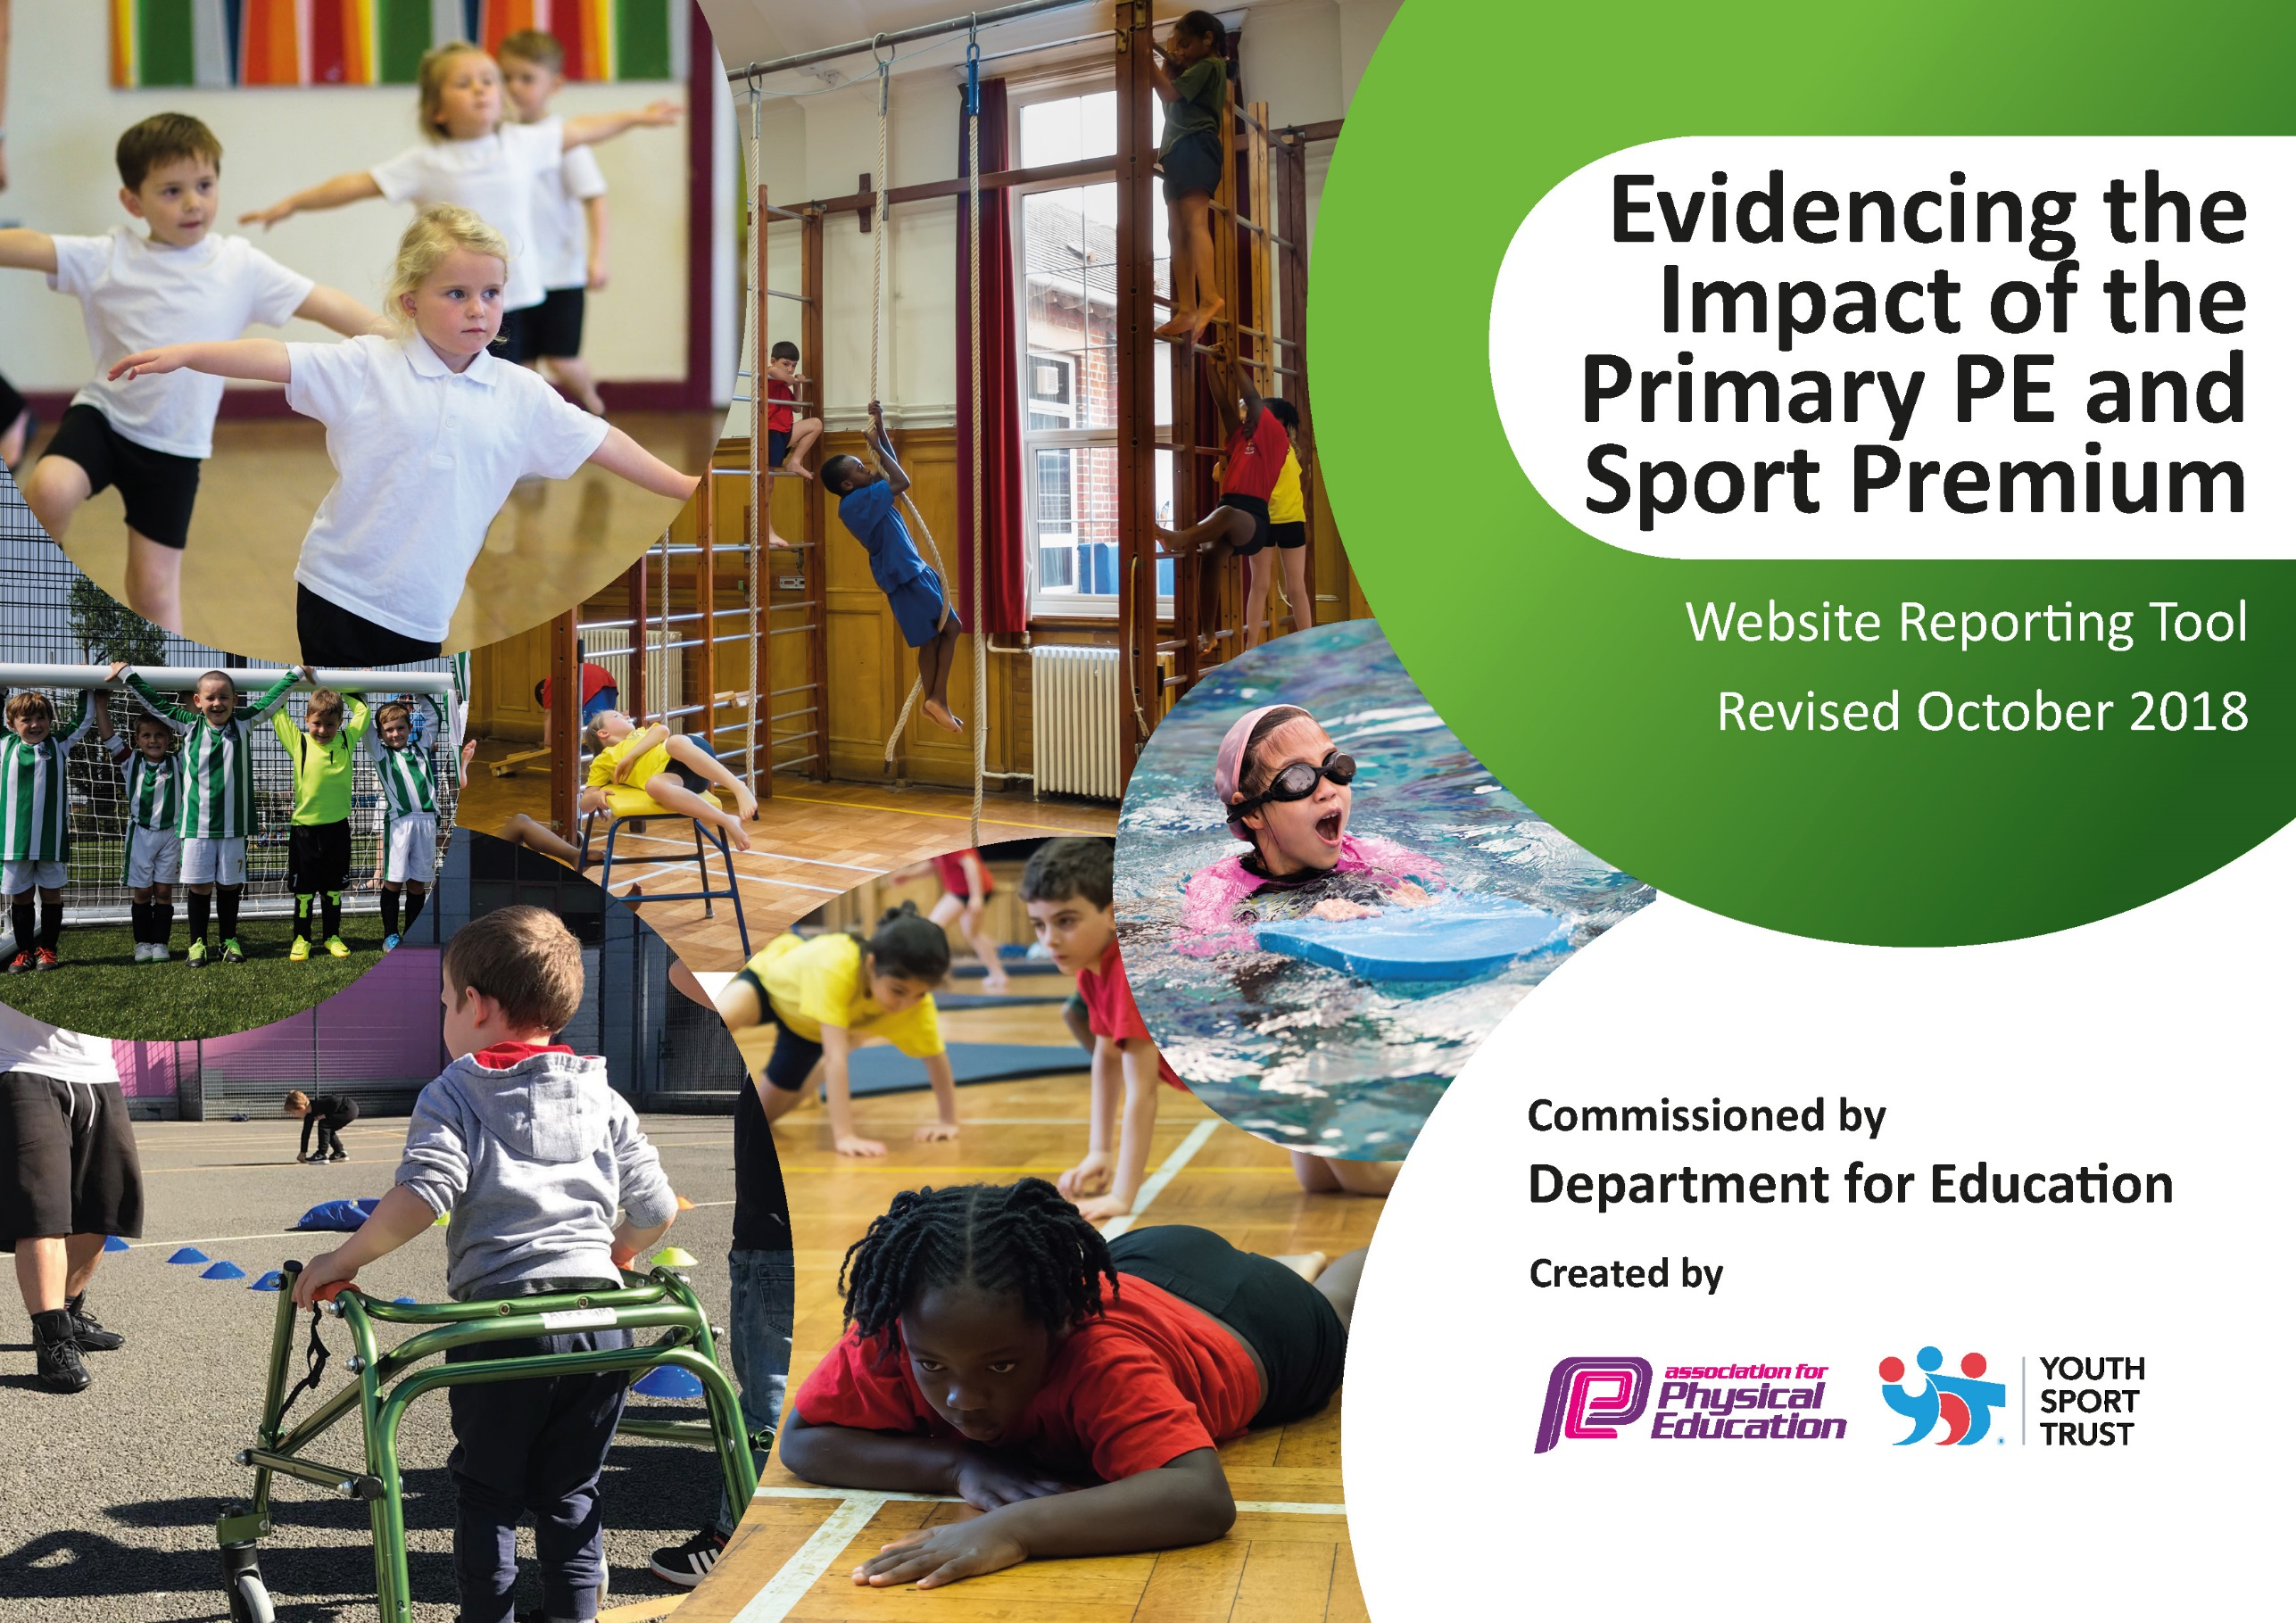
Evaluated Year 2018/19 Fairfield Primary School
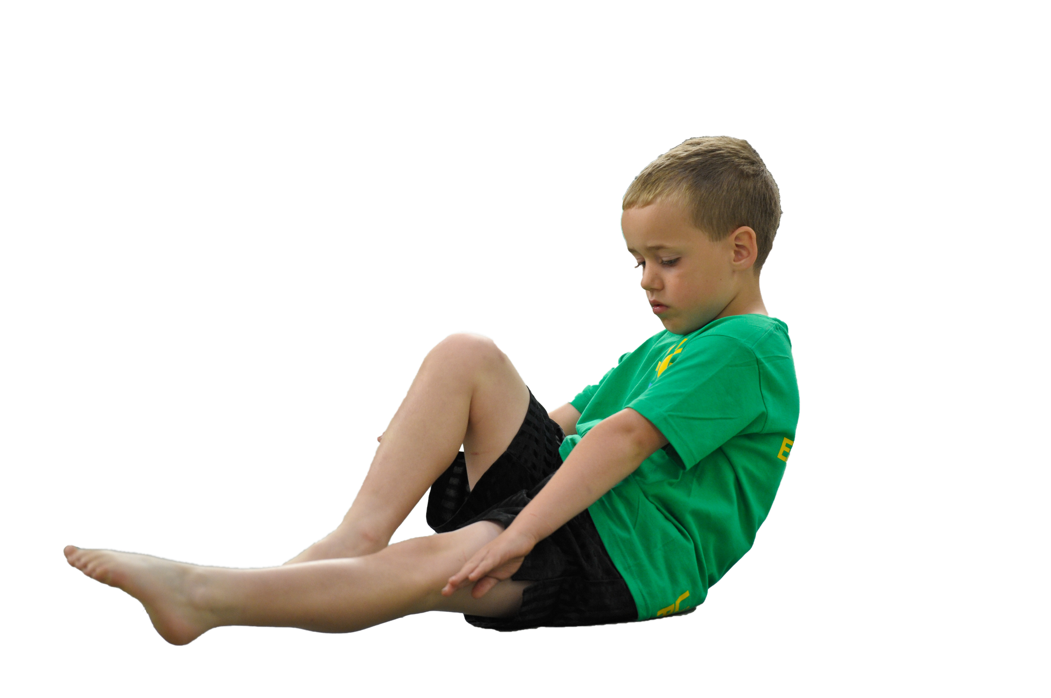
Schools must use the funding to make additional and sustainable improvements to the quality of Physical Education, Sport and Physical Activity (PESPA) they offer. This means that you should use the Primary PE and Sport Premium to:

- Develop or add to the PESPA activities that your school already offer
- Build capacity and capability within the school to ensure that improvements made now will benefit pupils joining the school in future years

Please visit gov.uk for the revised DfE guidance including the 5 key indicators across which schools should demonstrate an improvement. This document will help you to review your provision and to report
your spend. DfE encourages schools to use this template as an effective way of meeting the reporting requirements of the Primary PE and Sport Premium.

We recommend you start by reflecting on the impact of current provision and reviewing the previous
spend. Under the Ofsted Schools Inspection Framework, inspectors will assess how effectively leaders use the Primary PE and Sport Premium and measure its impact on outcomes for pupils, and how effectively governors hold them to account for this.

Schools are required to publish details of how they spend this funding as well as on the impact it has on pupils’ PE and sport participation and attainment by the end of the summer term or by 31 July 2019 at the
latest.
We recommend regularly updating the table and publishing it
on your website throughout the year, as evidence of your
ongoing review into how you are using the money to
secure maximum, sustainable impact. To see an
example of how to complete the table please
click HERE.

Support for review and reflection - considering the 5 key indicators from DfE, what development needs are a priority for your setting and your students now and why? Use the space below to reflect on previous spend, identify current need and priorities for the future.

Key achievements to date: | Areas for further improvement and baseline evidence of need:
Level 2 Sportshall athletics 5th place 2019
Year 6 football Cockermouth School competition Champions 2019
Level 2 Quick Sticks Hockey Regional Champions 2019
28 Children participate in Country Cross Country Competition. One Child finished 3rd and selected to compete in National Cross Country competition representing Cumbria. Year 5 girls team County Champions February 2019.
Level 2 Quicksticks Regional Champions February 2019
Year 6 Tag rugby Champions March 2019
Level 1 Year 4 tennis runners up March 2019
Rotary Football Competition Champions May 2019
Year 3 Mass participation Cross Country competition 52 children involved May 2019
Year 3 Mass participation rounders competition 52 children involved June 2019
Girls Cricket Competition June 2019
Level 1 Cricket Competition runners up June 2019
Cross Country Tri- Series finished 3rd overall with wins in individual categories over the series.
Touch rugby competition champions winning all categories Year 3/4 Boys, 5/6 Boys and Also 1st and 2nd Teams in the KS2 girls competition.
Level 3 County Quick Sticks Champions July 2019

‘Active Education’ Cumbria County Winners 2019
‘Healthy School of the Year’ National Winners 2019

Meeting national curriculum requirements for swimming and water safety | Please complete all of the below:
What percentage of your current Year 6 cohort swim competently, confidently and proficiently over a distance of at least 25 metres?  N.B. Even though your children may swim in another year please report on their attainment on leaving  primary school. | %
What percentage of your current Year 6 cohort use a range of strokes effectively [for example, front crawl, backstroke and breaststroke]? | %
What percentage of your current Year 6 cohort perform safe self-rescue in different water-based situations? | %
Schools can choose to use the Primary PE and Sport Premium to provide additional provision for swimming but this must be for activity over and above the national curriculum requirements. Have you used it in this way? | Yes/No

Action Plan and Budget Tracking
Capture your intended annual spend against the 5 key indicators. Clarify the success criteria and evidence of impact that you intend to measure to evaluate for students today and for the future.

Academic Year: 2018/19 | Total fund allocated: £ | Date Updated:
Key indicator 1: The engagement of all pupils in regular physical activity – Chief Medical Officer guidelines recommend that primary school children undertake at least 30 minutes of physical activity a day in school |  |  |  | Percentage of total allocation:
 |  |  |  | 6%
School focus with clarity on intended impact on pupils: | Actions to achieve: | Funding allocated: | Evidence and impact: | Sustainability and suggested next steps:
Develop play provision.  Sports equipment  Active Families based on parent’s feedback.  1K a Day | Outdoor timber trail to be extended in KS2. Timetabled sessions that link with the climbing wall and football provision. Gravel pit to be used by all KS1 children and KS1 play structure to be fitted. Playtime boxes to be monitored and kept full with purposeful equipment.  Purchase necessary high quality equipment to ensure sessions are effectively delivered.  Timetabled sessions that are devised with families personal targets as a key focus for each session.  Active families continues on Saturdays in conjunction with Wright Sports Services/Chance Camp.  Continue whole school involvement in 1K a day. | £500  £500  £0
Key indicator 2: The profile of PESSPA being raised across the school as a tool for whole school improvement |  |  |  | Percentage of total allocation:
 |  |  |  | 13%
School focus with clarity on intended impact on pupils: | Actions to achieve: | Funding allocated: | Evidence and impact: | Sustainability and suggested next steps:
Fully implement and utilise IPEP program, Maths of the day and 5-a-day across whole school.  Introduce 5 Steps to 5 stars programme to all classes.  Inter-house competitions are financially viable and can be developed to enhance in-school, inter-house competition.  Ensure continued use of Sports leaders for daily provision for all KS2 children. | Continue to schedule focused staff meetings where year group partners can monitor children’s progress and amend planning for the sequential terms.  PE sessions timetabled for each year group cross referenced with class overviews and whole school timetable for competitions ( Chris Wright Services, Allerdale and Cockermouth School Competitions) to ensure sustainability.  Work alongside Chris Wright to monitor Athletics progress and collect summative data for progression using the new scheme.  Develop league table and update Sports Board.  Complete in house competitions and share and record league tables. Develop a league in 2019/20 and link with Sports Day to monitor intra-school competition and whole school results.  Continued Sports Leader programme with new children trained to provide provision for KS2. Link with KS1 pupils in Summer 2 for transition session with the Sports Leaders on the KS2 yard. | £1000  £300  £200  £500

Key indicator 3: Increased confidence, knowledge and skills of all staff in teaching PE and sport |  |  |  | Percentage of total allocation:
 |  |  |  | 6%
School focus with clarity on intended  impact on pupils: | Actions to achieve: | Funding  allocated: | Evidence and impact: | Sustainability and suggested  next steps:
Provide additional CPD opportunities for staff for Gymnastics and core skills.  To further implement Maths of the Day inside and outside of the classroom. | Core sports i.e. High 5, Quick sticks, Quick cricket, Sportshall Athletics, Tag rugby to be explored and enhanced during twilight sessions to develop staff awareness and understanding of how the sport is played providing an opportunity to refresh knowledge prior to the upcoming competitions in the school timetable. KS1 staff member to attend UDANCE training.  Be a host school for CPD sessions with schools from our consortium.  Staff to continue recording MOTD in children’s books and lessons to be shared with parents on class dojo and on the school website. | £500  £500
Key indicator 4: Broader experience of a range of sports and activities offered to all pupils |  |  |  | Percentage of total allocation:
 |  |  |  | 66%
School focus with clarity on intended  impact on pupils: | Actions to achieve: | Funding  allocated: | Evidence and impact: | Sustainability and suggested  next steps:
Additional achievements:  Provide coaching in all areas of School Games sports.  Grand-day Out  Sports Development linked with CPD for staff  Swimming  UDance Competition | Review provisions provided by Connor Cooke- targeting all School Games Sports as well as Football.  A suggested £1 contribution to cover the cost of transport is required to ensure that the Grand Day Outs can take place.  Specialist coaches will continue to work alongside staff in school. They will work alongside the children to develop skills and also identify those who will benefit from after school sports development club.  Swimming lessons offered to Years 4 and 5. Monitoring the attainment of children in Year 4 and potentially offering lessons to Year 3 children in Spring 1.  Children who are unable to swim in Year 6 will attend lessons with the Year 5 children.  KS2 children to compete in dance competition against other schools in Allerdale. Mass participation. | £1000  £1000  £6000  £3000  £400
Key indicator 5: Increased participation in competitive sport |  |  |  | Percentage of total allocation:
 |  |  |  | 9%
School focus with clarity on intended  impact on pupils: | Actions to achieve: | Funding  allocated: | Evidence and impact: | Sustainability and suggested  next steps:
Maintain 75%+ of all children to participate in a competitive sport and target reluctant participants from 2018/2019 monitoring. | INSET DAY: participation records with staff and coaches who are responsible for organising competitions as they will choose, select and take their own class to competitions.  Up to date coaching and competition calendar issued to staff.  Participate in Allerdale, Cockermouth and Wright Sports Services Multi Skills and Football competition in addition to Level 2 Sports. | £0  £0  £1600

