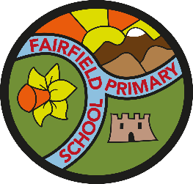
School Council

Minutes of the meeting held on Monday 15th October 2018
Present: Only 1 member of the Year 2 representatives was absent from this meeting.
Minutes of the last meeting: N/A
Agenda:
Miss Edminson, Mr Gale and Miss Robinson shared the provisional Charity Calendar with the children- which had been created by last year’s School Council.
The children all agreed that these were good ideas, but decided that we may not have time to collect donations for the Food Bank during October.
One member of the School Council then mentioned that they have organised a Bake Off Event to coincide with the PTA Christmas Fair. This would be to help raise money for ‘Save the Children’.
It was also agreed that the Year 6 members of the School Council would take the Poppy Appeal items around school, to collect donations for the Royal British Legion.

Follow up research:
The School Council will now go back to their classes and find out what the children would like to further improvement about the school. This will become the basis of our future School Council projects.

