FAIRFIELD PRIMARY SCHOOL
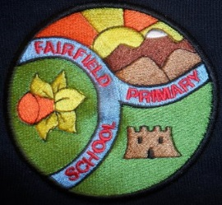

Forest School Handbook
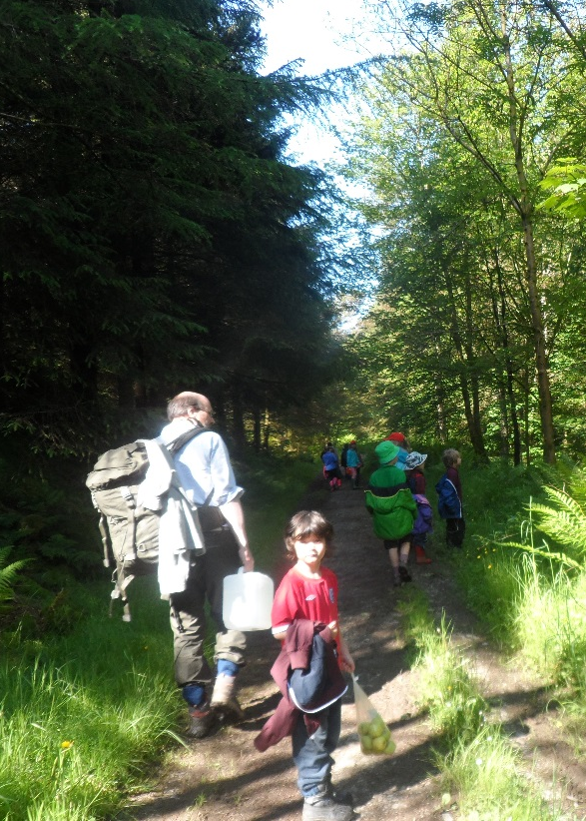

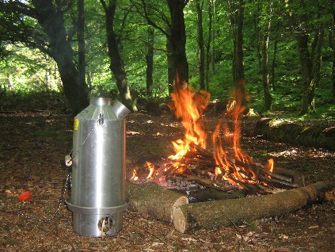
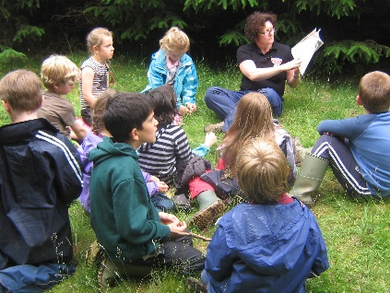
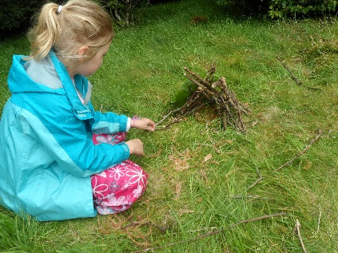

Contents:
Purpose of Forest School
Ecological Impact
Countryside Code
Forest School Rules
Forest School Routine
Toileting Consideration
Role Specification
Clothing Requirements
Equipment
Legislations related to Policies and Procedures
Health and Safety Procedure
Site Risk Assessment and Risk Management
Tool Risk Assessment
Fire Policy
Medical Procedures
Accident and Emergency Procedure
Purpose of Forest School
Forest School sessions provide children with the opportunity to explore and experience the natural world through practical activities in the outdoors which will in return help promote confidence, independence and self-esteem. Also by using resources available in the wood and the children’s interests we hope to stimulate further imagination, creativity and enquiry skills. Forest School sessions shall not be limited to children of a certain age instead all children will have the opportunity to attend sessions before they leave the school. Most children will visit the site regularly throughout the year and in all weather!

Ecological Impact
Whilst using the Forest School site we shall try and minimise the harm caused to local plant species and wildlife. The site is also likely to incur a higher level of erosion due to increased use. During the Forest School sessions the children shall be encouraged to be more responsible for the protection of plants and wildlife. We shall also work to improve the site to encourage further wildlife. We shall abide by The Countryside Code as well as The Forest School Rules.

The Countryside Code
There are five sections of The Countryside Code dedicated to helping us learn how to respect, protect and enjoy the countryside:
• Be safe, plan ahead and follow any signs
• Leave gates and property as you find them
• Protect plants and animals and take your litter home
• Keep dogs under close control
• Consider other people

Forest School Rules
• Look after your Forest School
• Do not pick anything growing
• Do not put your fingers or anything else in your mouth
• Stay within the boundaries marked, we don’t go over it and we don’t go under it
• Stay outside of the fire circle – unless invited in by an adult
• Look up, look down and all around for hazards.

Forest School Routine
Procedures to be carried out before each session:
• A thorough sweep of the site will be done before each session to check for any litter, glass, animal faeces etc. Any such items shall be collected using plastic bags and disposable gloves.
• A written record will be kept of any problems found during sweep. This shall state if any hazards were found and how they were dealt with.
• Trees will be checked for any broken or dead branches which may fall.
• Check of weather conditions. If it is unduly windy or a thunder storm is imminent or has commenced then it will not be advisable to carry out a Forest School session.

Session Outline:
• Collect children and talk about session ahead. Instructions for clothing; toilet and getting ready to go. Share out things to carry. Check numbers. Check inhalers.
• Board minibus. Seatbelts on. Travel to site.
• DCE to unlock gate. SS to attach ‘Fairfield Forest School – please leave access’ note to gate. Children remain in seats with belts on.
• DEC closes gate behind bus and drives to parking place. Unload; share equipment to carry. Walk to site. Leader at front; TA at back; depending on group dynamics and activity planned.
• Walk to base camp.
• Sit down discuss rules. Children to walk the boundaries in groups and identify hazards. Sit together and discuss safety issues again. N.B. If a child identifies a potential hazard have them place a flag near it and tell an adult.
• Provide instructions for the session, identifying resources and session focus. • Children to have time exploring. • Snack time ensuring children have cleaned their hands with wipes first. • Discuss session, allowing children to feedback if they wish to.

Procedures to be carried out at the end of each session:
• Collect resources in containers (check all are returned) and ensure forest school area is tidy.
• Children to walk to the minibus.
• Drive back to gate. Unlock; drive through; re-lock and remove note.
• Return to school. Return resources to the storage area. Remove outdoor clothing. Wash hands.

Toileting Procedure:
The school has a portable toilet and ‘tent’: if a child needs the toilet they have to inform a member of staff who will then give them permission to use it. At the end of the session all waste will be buried in a pit by the Forest School leader.

Role Specifications
Forest School Leader – David Edwards
• To ensure the safety of children and adults as they travel to and from the forest school site.
• Ensure the safety of children and adults whilst at the site.
• Provide clear guidance and expectations to adults and children.
• Carry out a safety check of the site prior to visiting.
• To assess the site on a quarterly basis.
• Carry out a safety sweep before each session

Support Staff – Sue Sharp (or other designated TA)
• Ensure the safety of children and adults as they travel to and from the forest school site.
• Partake in children’s activities.
• Ask open ended questions rather than directing them to activities/ telling them what to do.
• Record observations.

Parent Helper (if present)
• Assist with carrying resources to and from site.
• Partake in children’s activities.
• Ask open ended questions rather than directing them to activities/ telling them what to do.
• Follow instructions from the Forest School Leader or Support Staff.

Clothing Requirement (for everyone)
• Woolly hat/ Sun hat • Gloves • Jacket/ waterproof coat • Fleece/Jumper • waterproof trousers/ Long trousers • Spare socks • Sturdy Footwear- Trainers/Wellies/Boots • An emergency change of clothes and a carrier bag for dirty/wet clothing
N.B. There will be a small number of waterproofs and extra clothing available.

Equipment
• Emergency Bag (kept in a backpack) • Register with emergency numbers/contact numbers
• Medical forms • Mobile phone/ Means of communication • Newspaper • Matches • Wet wipes • Protective gloves • First aid kit including plasters, bandages and scissors. • Water bottle
• Blanket • Species List for site • Container for medical items • Carrier Bags
• Hot chocolate and snack • Risk assessment

Possible Activity Equipment
• Trowels and rakes • Magnifying glasses • Identification books • Local Wildlife Puppet i.e. Rabbit for base camp/ small mouse for sharing time. • Bird song Birds • Buckets/ Pots • Paintbrushes • Fire pit • String • Bow saw • Penknife
*Any further equipment taken to the site must be deemed appropriate by Forest School Leader.

Health and Safety Policy
Fairfield Primary School Health and Safety Policy (See Separate Document) sets out a clear statement of intent regarding the School’s approach to the health and safety of its children, staff and visitors to the School. The following is a 10 point list of additional measures relating directly to Forest School sessions.
1. However many adults accompany Forest School sessions the person in charge is always the trained Forest School Leader.
2. The Forest School Leader has overall duty of care for the children in his/her charge, but all adults are required to take all reasonable steps to ensure children are safe.
3. All adult helpers must sign and date a form to show they have read this handbook and appropriate risk assessments and understand and agree to comply with the general operating procedures for Forest School.
4. Whenever sessions are being carried out the Forest School Leader will inform staff of the group’s whereabouts and for how long we intend to stay.
5. The Forest School Leader or Assistant will carry the Emergency Bag.
6. The Forest School Leader will ensure that the Emergency Bag contains:
• Essential survival equipment; • A contact list for each child undertaking the activities, and; • The School’s telephone number.
7. The Forest School Leader will always carry a mobile phone.
8. In the event of an emergency, the Forest School Leader will ensure that the School contacts the emergency services.
9. The Forest School Leader will review the risk assessments before every session.
10. When tools are used the adult: child ratio will always be 1:1

Legislation Related to Policies and Procedures
• Health & Safety at Work Act 1974
• Children’s Act 1989
• Liability Insurance
• The following laws and guidance - Disability Discrimination Act Race Relations Act Sex Discrimination Act CRB Checks Every Child Matters

Risk Assessment for tools
General rules for tool use: • All tools must have an individual risk assessment in Health and Safety folder • Ensure safe storage at school with nominated Forest School Leader access and responsibility • Ensure safe storage and responsibility by Forest School Leader at the Forest School Site • Never walk around with tools. • Always make sure they are clean and sharp before using them. • When using tools with children it should only be with the Forest School Leader. • When using tools there is a designated tool area where the Forest School Leader and child will sit when using the tool. • First aiders and first aid kit close by.

Fire Policy
Aim- To use fire safely as part of the Forest School experience.
Method Fires must only be lit after a risk assessment has been carried out and they must only be within the fire circle area surrounded by a wind break fence. This includes the use of Kelly Kettles. There must always be a trained adult present within the fire circle when a fire is lit or hot embers remain, never leave a fire unattended.
There must be an adequate supply of fire water close to the fire basket to ensure there is enough water available to extinguish the fire if it gets out of control. Fire proof gauntlets should be kept at the fire area to allow adults to pick up hot items.
Before visiting the area the children should have had the opportunity to ask questions and be given information about fire safety. When at the fire circle the rules should be demonstrated for the children to see. There should be no more than 4 people, adults and children, within the fire circle next to the fire at any one time. The best position for cooking is on one knee so you can move backwards easily and remain stable. Long hair should be tied back and scarves removed.

Medical Procedure
Parents shall be asked to complete a medical form when they give permission for their child to attend forest school. The form shall be carried at all times in case of an emergency.
Accident and Emergency Procedure
If an emergency occurs on a school visit the group leader should maintain or resume control of the group overall. He will, however, delegate responsibility when necessary, so all adults accompanying the visit must read and sign the visit handbook before the trip begins.
The group leader will: Establish the nature and extent of the emergency as quickly as possible. Ensure that the entire group are safe and looked after and kept together. All other adults will be told as soon as possible and allocated roles; roles may be changed as needed. Establish the names of any casualties and get immediate medical attention. Children’s names and medical details will be in the emergency bag. First Aid box will be on site. Phone for an ambulance if appropriate. Another adult may be asked to do this. Ensure that a teacher or teaching assistant accompanies casualties to hospital with any relevant medical information. In extremis a CRB checked adult may have to take this role. Inform the school of the name of the casualty and details of their injuries plus action taken so far. Head will notify the police if necessary. Pass on to school details of nature, date and time, location of the incident. Head will notify parents, providing as full a factual account of the incident as possible. Write down accurately and as soon as possible all relevant facts and witness details and preserve any vital evidence. Keep a written account of all events, times and contacts after the incident. The group leader will give copies of notes and reports to the headteacher. Complete an accident report form as soon as possible.
Keep receipts for any expenses incurred – insurers will require these.
NB: No-one in the group should speak to the media. Any enquiries from journalists must be referred to the headteacher. No-one in the group should discuss legal liability with other parties, nor sign anything relating to accident liability without clear advice from the LA or relevant Union.

Scenarios
First aid 1. Ensure the rest of the group are safe – where appropriate delegate responsibility. 2. If appropriate, remove the danger or people from the danger. 3. Qualified First Aider called to check A-B-C, administer First Aid and if necessary call for further assistance (999). 4. Have medical form details available in emergency bag and call parent/guardian as appropriate. 5. Record full details through school incident procedure back at school. 6. Follow up to parents as usual.
Lost or missing child 1. As soon as child is found to be missing, make an immediate search of vicinity and use 1, 2, 3 procedure. 2. Assemble rest of children and ensure they are safe. 3. Call school to alert and then school calls police (and parent/guardian). 4. Follow school critical incident procedure.
Death or serious accident 1. Follow First Aid procedure. 2. Stay with casualty, but ensure rest of group is removed from the situation and are safe. 3. School to call parent/guardian/next of kin ASAP. 4. Follow school critical incident procedure. 5. Gain advice on follow up from police.
Irregular occurrence, uninvited person/stranger 1. The intruder will be challenged and asked to leave politely. 2. If a child is involved then the police should be called and the child/children involved should be removed from the situation and made to feel safe. 3. Follow school’s critical incident procedure 4. Parents/guardian should be briefed by Forest School leader asap. 5. Inform Safeguarding officer and gain advice.
Poor weather conditions 1. If trees blowing more than 20 degrees, or if group leader feels uncomfortable take emergency ‘safe’ route out ASAP. 2. Use alternative areas or shelter outdoors (away from trees).
Behaviour problems 1. Trained members of staff to use de-escalation strategies. 2. Remove other children from area of risk (if deemed necessary). 3. If thought necessary, trained members of school staff to use appropriate restraint technique. 4. Debrief child after calm down period. 5. Log incident. 6. Inform parents/guardian.

